SECTION I: INITIATION OF CAPA PROPOSAL
ORIGINATOR | CORRECTIVE ACTION PREVENTIVE ACTION
 | INITIATED BY: Ethan Rao |  |  |  | DATE: 30 July 2025
DETAILED DESCRIPTION OF NON-CONFORMANCE/OPPORTUNITY FOR IMPROVEMENT:

On 5 occasions over a period of 3 years, it was reported to Silq that the port allowing connection of the saline syringe to the catheter became unseated from the catheter when the syringe was being connected. The check valve on the catheter is not always seated completely flush against the catheter tubing. The gap between the check valve and tubing varies from sample to sample. See image below of a catheter sample with a gap between the valve and the tubing.

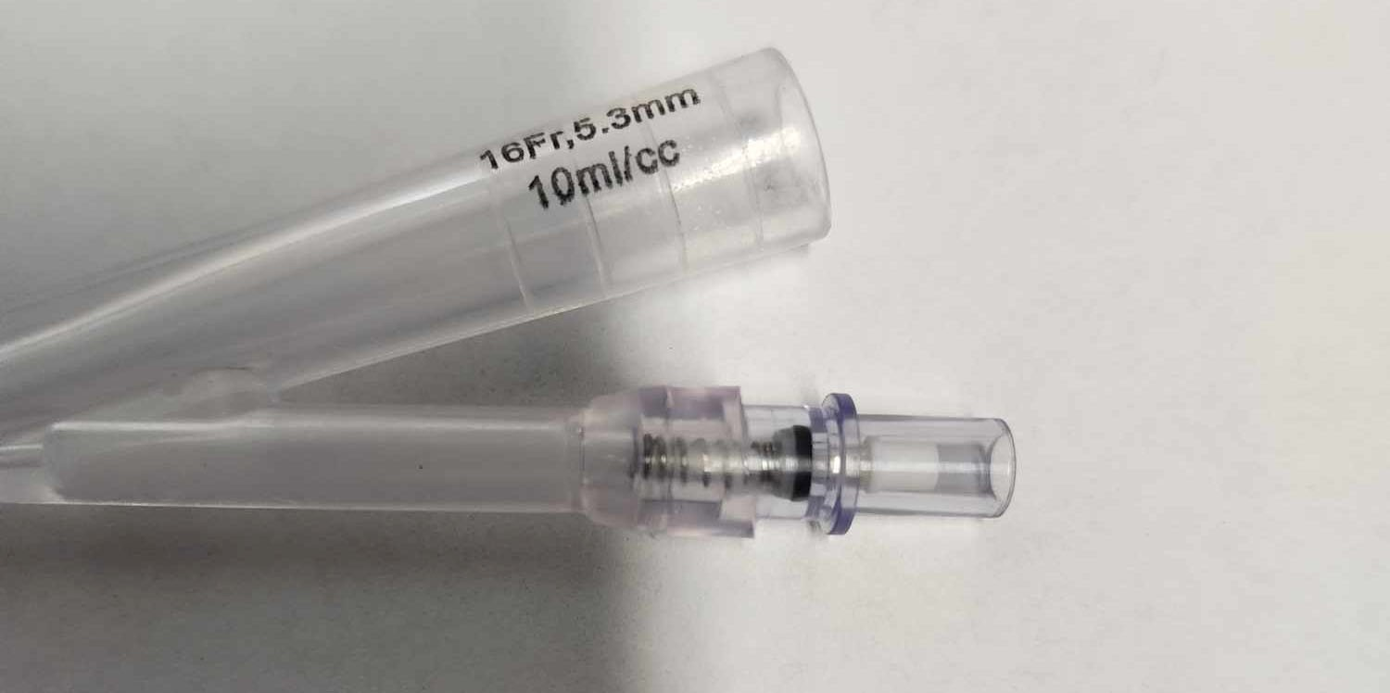
Valve placement with gap:

Valve Gap Length

SOURCE OF INFORMATION (NCMR#, COMPLAINT#, OBSERVATION, ETC.): PCFs: 2022002 (Lot HDX-8006110821),
2023002 (Lot SLQ1610-012022), 2024002 (Lot SLQ-81020403231), 2024003 (Lot SLQ-81040413231), and 2025001 (Lot
SLQ-81040413231)

SECTION II: INITIAL INVESTIGATION BY QA
QUALITY | INITIAL INVESTIGATION (INCLUDE ACTIVITY, RESULTS AND RECOMMENDATION):  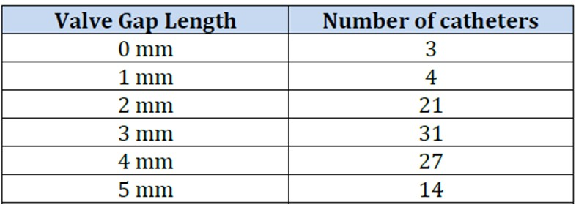  In June 2024, following PCF2024003, A random sampling of 100 16Fr x 10mL catheters were pulled from inventory, and the gap was measured. There was great inconsistency in how the valves are placed. The results are summarized in the table below:  Contact was made with the Pathway MedTech, a contract manufacturer and the supplier of the untreated catheters to Silq. Subsequently, the manufacturer of the untreated catheters was notified and an agreement was made on November 6th, 2024 to use an improved valve that ensures secure placement and prevents dislodgement on future shipments of the untreated catheters. Because the issue occurred on a small percentage of total units and presented no significant risk to patients, no additional design changes or inspection processes were implemented at that time. Following PCF2025001 reported in July 2025, the first instance of the issue since the June 2024 investigation, this CAPA was initiated by Ethan Rao with the intent to review all Silq catheters in inventory that were manufactured with untreated catheters obtained prior to November 6th, 2024. Units that meet either of the criteria listed above will be removed from inventory and used for research and development purposes. The relevant lots are Lot SLQ-11202024 and Lot SLQ-05012025
SECTION III: APPROVALS TO OPEN or REJECT BY CAPA TEAM
CAPA TEAM | Approved Rejected | If rejected, provide rationale:
 | ASSIGNED CAPA OWNER: Ethan Rao
 | 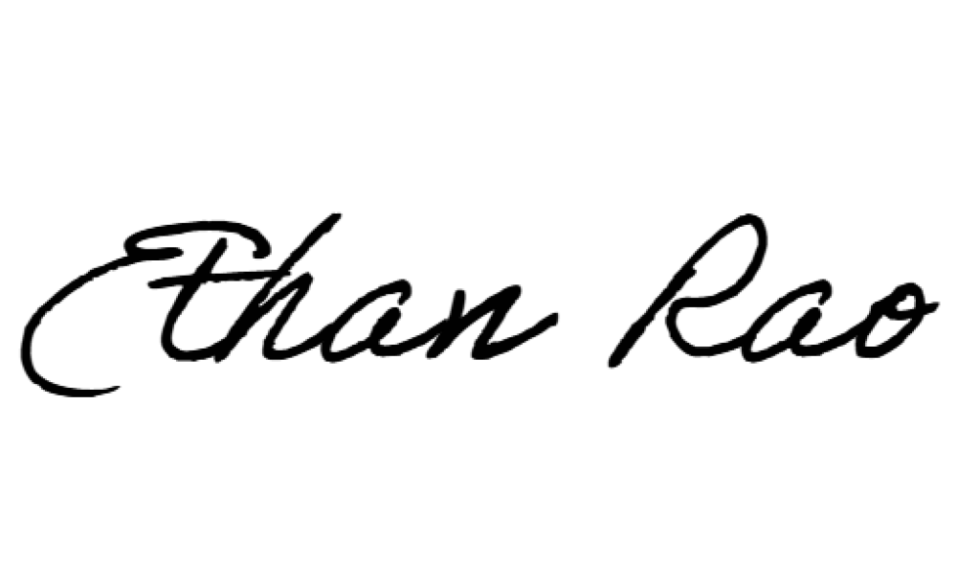  Quality Assurance: |  | Date:  15 Aug 2025 | R&D/Engineering: |  | Date:  15 Aug 2025
 | 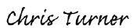  MFG / Operations: |  | Date:  15 Aug 2025 | Other: |  | Date:
 | Other: |  | Date | Other: |  | Date:

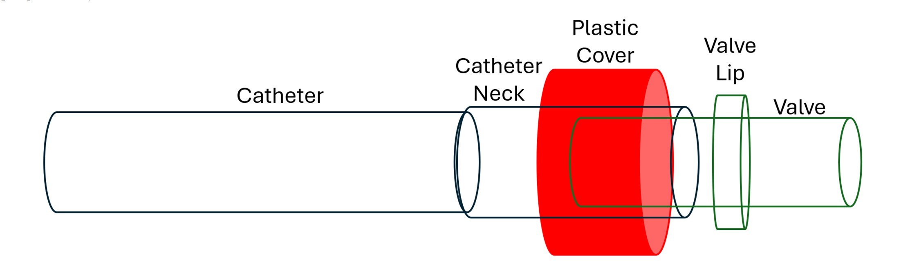
SECTION IV: INVESTIGATION AND DETERMINATION OF ROOT CAUSE
OWNER

Silq researchers continued to evaluate the 100 randomly sampled catheters and established criteria that could potentially be
used for a non-destructive evaluation of the existing inventory to identify any units where this issue may occur. The
proposed rejection criteria were as follows:

1)
The check valve is not securely and properly seated to the catheter neck connector.
The maximum length from the plastic cover to the end of the valve should be less than 26mm.
2)

RISK / HAZARD ANALYSIS SUMMARY
)
SAFETY ISSUE ONLY
(

:
Non-conformance presents only a remote risk the patient will
need to seek a premature catheter exchange. No patient injuries as a result of the nonconformance have been reported

DOES THE RISK MANAGEMENT REPORT NEED TO BE UPDATED:

YES

NO
THERE ARE NO NEW FAILURE MODES,
(
INCREASE IN INCIDENCE, OR HAZARDS)
ANALYSIS COMPLETED BY: Ethan Rao

DATA ATTACHED:
DATE: 11 Nov 2025

YES

NO

SECTION V: CORRECTIVE ACTION or PREVENTIVE ACTION PLAN
OWNER | # | CORRECTIVE / PREVENTIVE ACTION: | RESPONSIBILITY: | ESTIMATED DATE ACTION WILL BE IMPLEMENTED:
 | 1 | 100% visual/dimensional inspection of the SLQ-211610SPT finished goods | Ethan Rao | 18 Nov 2025
 | 2 | Revision of device drawings to reflect updated specifications for conformance | Ethan Rao | 18 Jan 2026
 | JUSTIFICATION FOR THE PLANNED ACTION(S): Per the investigation in Section IV, it was determined that a non destructive visual/dimensional inspection of the SLQ-211610SPT finished goods is appropriate to identify any units that could potentially exhibit nonconforming attributes.
DOCUMENT CONSIDERATION THAT THE ACTION(S) DOES NOT ADVERSELY IMPACT PRODUCT OR SYSTEM: Non-
conformance presents only a remote risk the patient will need to seek a premature catheter exchange. There is no potential adverse impact on finished goods
 | RESPONSIBLE DEPARTMENT MANAGEMENT ACTION PLAN APPROVAL: |  | DATE:  01 Sep 2025
 | ACTION PLAN SUMMARY COMPLETED BY: Ethan Rao |  | DATE: 01 Sep 2025
 | DATE ACTION PLAN IMPLEMENTATION COMPLETE: 18 Nov 2025 | Owner Signature: | DATE:  17 Nov 2025
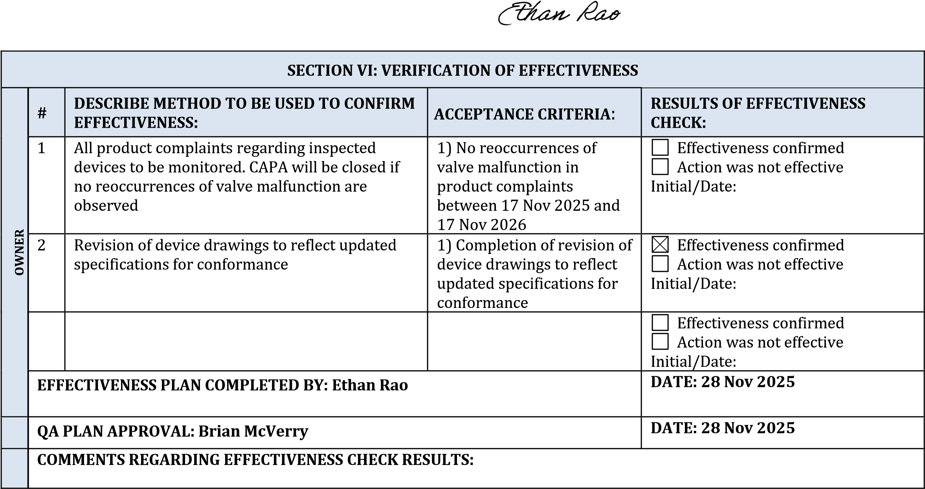
SECTION VII: CAPA TEAM APPROVAL to CLOSE CAPA – ACTIONS EFFECTIVE
CAPA TEAM | CAPA CLOSED | Comments:
 | Quality Assurance: |  | DATE: | R&D/Engineering: | DATE:
 | MFG / Operations: |  | DATE: | Other: | DATE:
 | Other: |  | DATE: | Other: | DATE:

